Bangladesh Medical Association (BMA)
List of Life Member-231
49. BMA Noakhali Branch

Sl No | Voter No | Voter Details
1 | Voter No  LM-4900001  No Image | DR. A. K. SHAFIQ UDDIN AHMAD  F/Name: Late Monsoor Ahmed  M/Name:  BM & DC Reg. No:  NID:  Cell:  Address: Hospital Road , Maizdee Court  Noakhali  Blood Group:
2 | Voter No  LM-4900002  No Image | DR. MOHAMMAD ABDUL QUAYYUM  F/Name: Dr. Abdul Hai  M/Name:  BM & DC Reg. No:  NID:  Cell:  Address: Chowmuhani General Hospital  Chowmuhani  Noakhali  Blood Group:
3 | Voter No  LM-4900003  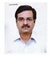 | DR. MAMUN-AR- RASHID  F/Name: Mr. Salamot Ullah  M/Name: Mrs. Moryium Begum  BM & DC Reg. No:  NID:  Cell:  Address: Noakhali Private Hospital Ltd.  Hospital Road  Maijdee Court,  Noakhali  Blood Group:
4 | Voter No  LM-4900004 | DR.MD. GULAM HAIDER  F/Name: Al-haz Khizir Ahamed Chy.  M/Name:  BM & DC Reg. No:  NID:  Cell:  Address: Mobarak Cottage  Islamia Road  Maijdee Court, Noakhali  Blood Group:
5 | Voter No  LM-4900005  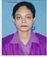 | DR. HUMAIRA AHMED  F/Name: Late Dr. Ali Ahmed  M/Name: Mrs. Selina Ahmed  BM & DC Reg. No:  NID:  Cell:  Address: Noakhali Private Hospital Ltd.  Hospital Road  Maijdee Courd, Noakhali.  Blood Group:
6 | Voter No  LM-4900006  No Image | DR. MD. ABDUL HAI  F/Name: Late Md. Abdul Majid  M/Name:  BM & DC Reg. No:  NID:  Cell:  Address: Good Heal Hospital  Hospital Road  Maijdee Courd,  Noakhali  Blood Group:
7 | Voter No  LM-4900007  No Image | DR. PERVAIZ RUQAYA KHANAM  F/Name: Late Dr. M. M. Hossain Khan  M/Name:  BM & DC Reg. No:  NID:  Cell:  Address: Nadia Nursing Home Housing Estate  Maijdee Court  Noakhali  Blood Group:
8 | Voter No  LM-4900008  No Image | DR. MD. FAZLUR RAHMAN CHOWDHURY  F/Name:  M/Name:  BM & DC Reg. No:  NID:  Cell:  Address: Senior Consultant Ortho. Surgery  OSD. D.G. Health,  Bangladesh Secretariat Clinic, Dhaka.  Blood Group:  TRANSFERED to BMA Dhaka City  LM-1405543
9 | Voter No  LM-4900009  No Image | DR. MIZANUR RAHMAN  F/Name: Hazi Lutfur Rahman  M/Name:  BM & DC Reg. No:  NID:  Cell:  Address: Noor X-Ray Clinic  Mofiz Plaza, Main Road  Maijdee Court  Noakhali  Blood Group:
10 | Voter No  LM-4900010  No Image | DR. DAS RANJIT KUMAR  F/Name: Mr. Shyam Lal Das  M/Name:  BM & DC Reg. No:  NID:  Cell:  Address: Central Road  Housing Estate  Maijdee Courd, Noakhali  Blood Group:
11 | Voter No  LM-4900011  No Image | DR. ROKEYA KHANAM  F/Name: A.k. M. Bashirul Hossain Khan  M/Name:  BM & DC Reg. No:  NID:  Cell:  Address: Chowmuhani General Hospital  Chowmuhani ‘  Noakhali.  Blood Group:
12 | Voter No  LM-4900012  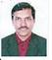 | DR. PRABIR KUMAR BHOWMIK  F/Name: Late Dwijendra Kumar Bhowmik  M/Name:  BM & DC Reg. No:  NID:  Cell:  Address: Hoque Villa, Main Road  Maijdee Court  Noakhali  Blood Group:
13 | Voter No  LM-4900013  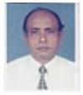 | DR. MD. MOFIZUL ALAM  F/Name: Ruhul Amin  M/Name:  BM & DC Reg. No:  NID:  Cell:  Address: Central Road  Housing Estate  Maijdee Courd,  Noakhali  Blood Group:
14 | Voter No  LM-4900014  No Image | DR. MD. ABDUL AWAL MIA  F/Name:  M/Name:  BM & DC Reg. No:  NID:  Cell:  Address: Housing Estate  Maijdee Courd,Noakhali.  Blood Group:  TRANSFERED to BMA Dhaka City  LM-1405543
15 | Voter No  LM-4900015  No Image | DR. MOHAMMED SADIQUR RAHMAN  F/Name: Abdur Rahman  M/Name:  BM & DC Reg. No:  NID:  Cell:  Address: Police Officer  Noakhali  Blood Group:
16 | Voter No  LM-4900016 | DR. MOHAMMAD FEROZ  F/Name: Dr. Mosharraf Hossain Khan  M/Name:  BM & DC Reg. No:  NID:  Cell:  Address: Civil Surgon Office  Noakhali  Blood Group:
17 | Voter No  LM-4900017 | DR. MD. SANAULLAH MEAH  F/Name: Abul Hashem Meah  M/Name:  BM & DC Reg. No:  NID:  Cell:  Address: Sr. Consultant Paediatrics  General Hospital  Noakhali  Blood Group:
18 | Voter No  LM-4900018  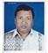 | DR. MD. MASUM AKHTER  F/Name: Late Abdul Motin  M/Name:  BM & DC Reg. No:  NID:  Cell:  Address: Azad Monjil, Hospital Road  Maijdee Court  Noakhali  Blood Group:
19 | Voter No  LM-4900019  No Image | DR. MD. SHAHID ULLAH  F/Name: Late Mohd. Harunor Rashid  M/Name:  BM & DC Reg. No:  NID:  Cell:  Address: Consultant, Gynae  General Hospital  Noakhali  Blood Group:
20 | Voter No  LM-4900020  No Image | DR. SALMA SULTANA  F/Name: Md. Solaiman Ahmed Mullah  M/Name:  BM & DC Reg. No:  NID:  Cell:  Address: Nishat Monjil, Housing Estate  Maijdee Courd,  Noakhali  Blood Group:
21 | Voter No  LM-4900021 | DR. MD. ABU NASER  F/Name: Mokbul Ahmed Mollah  M/Name:  BM & DC Reg. No:  NID:  Cell:  Address: Rabeya Private Hospital. College Road  Chaumuhani  Noakhali.  Blood Group:
22 | Voter No  LM-4900022  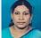 | DR. SULTANA RABEYA KHANAM  F/Name: Late Rafiyet Ullah  M/Name:  BM & DC Reg. No:  NID:  Cell:  Address: Rabeya Private Hospital. College Road  Chaumuhani,  Noakhali.  Blood Group:
23 | Voter No  LM-4900023  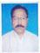 | DR. A.N.M. SHAMSUL KARIM  F/Name: Md. Shujayet Ullah  M/Name:  BM & DC Reg. No:  NID:  Cell:  Address: Bhaba Bhadri, Chandrogonj  Begumgonj  Noakhali.  Blood Group:
24 | Voter No  LM-4900024  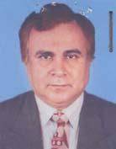 | DR. S.M. IBRAHIM  F/Name:  M/Name:  BM & DC Reg. No: 7914  NID: 7528704122776  Cell: 01711735513  Address: Upazila Health & F.P. Officer Sadar Upazila, Noakhali  Blood Group: O+  TRANSFERED to BMA Dhaka City  LM-1405543
25 | Voter No  LM-4900025  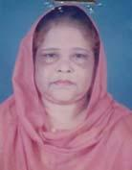 | DR. SHAMSUN NAHAR  F/Name:  M/Name:  BM & DC Reg. No: 10851  NID: 7528704122777  Cell: 01711038798  Address: Medical Officer, Sadar Upazila Health Complex, Noakhali  Blood Group: B+  TRANSFERED to BMA Dhaka City  LM-1405543
26 | Voter No  LM-4900026  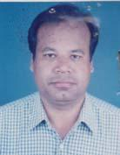 | DR. MD. KARIMUL HUDA SHIRAJI  F/Name: Late Anwar Ullah Shiraji  M/Name: Monwara Begum  BM & DC Reg. No: 19063  NID: 7528704122582  Cell: 01711735719  Address: Jr. Consultant, Cardiology, Upazila Health Complex, Conpanigonj, Noakhali  Blood Group: B+
27 | Voter No  LM-4900027  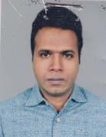 | DR. NUPUR KAR  F/Name: Nirmal Kar  M/Name: Maya Kar  BM & DC Reg. No: 25791  NID:  Cell: 01711708825  Address: Maijdee, Noakhali  Blood Group: O+
28 | Voter No  LM-4900028  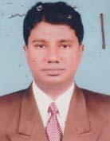 | DR. NUR MUHAMMED  F/Name: Hazi Monu Miah  M/Name: Mrs. Halima Khatun  BM & DC Reg. No: 23330  NID: 7520708506427  Cell: 01711890478  Address: Dream Hospital, Read Mension, Feni Road, East Bazar, Chowmuhani, Noakhali  Blood Group: B+
29 | Voter No  LM-4900029  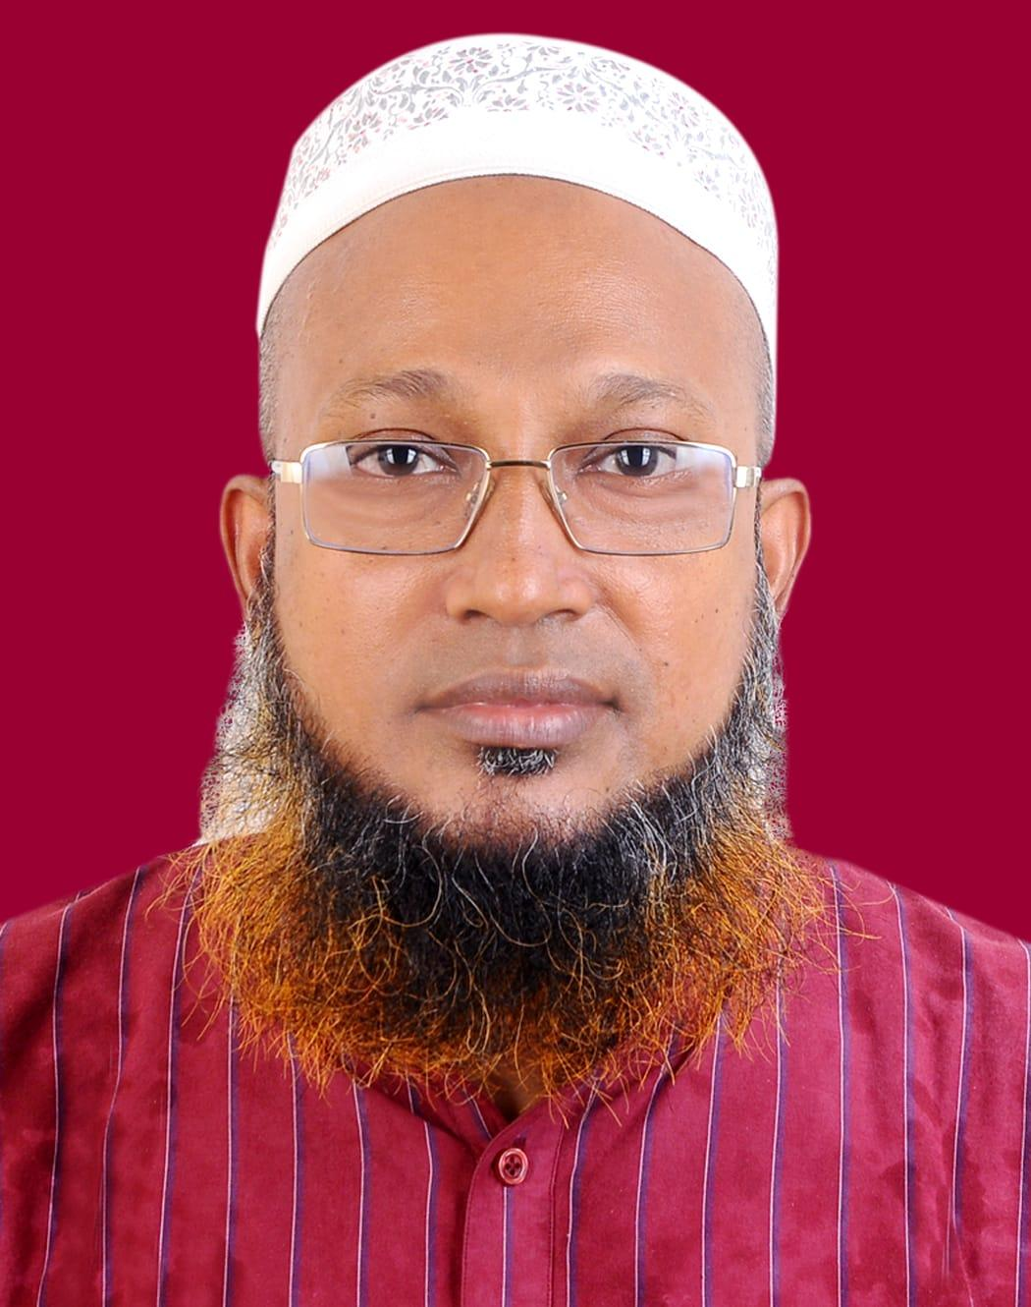 | DR.ABDUS SATTER  F/Name: Mr. Shamsal Huda  M/Name: Mrs. Salema Khatun  BM & DC Reg. No: 40183  NID: 8690834349  Cell: 01815-572520  Address: C/O Niramoy hospital Ltd, Abdul Malek Ukil road( main road) , Maijdee, Noakhali.  Blood Group: O-
30 | Voter No  LM-4900030  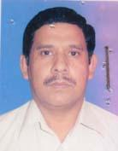 | DR. SALAUDDIN MAMUN CHOWDHURY  F/Name: Late Shamsul Huda Chowdhury  M/Name: Late Mrs. Ambia Khatun  BM & DC Reg. No: 22241  NID:  Cell: 01819434914  Address: Anawer Mention, Central Road Housing, Maijdee, Noakhali  Blood Group: O+
31 | Voter No  LM-4900031  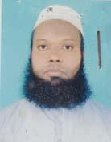 | DR. A.F.M. ABDUL HOQUE  F/Name: Mohammad Saidul Hoque  M/Name: Joinab Bibi  BM & DC Reg. No: 37006  NID: 7512123131536  Cell: 01721123316  Address: Medical Officer, Upazilla Health Complex, Companigonj, Noakhali  Blood Group: B+
32 | Voter No  LM-4900032  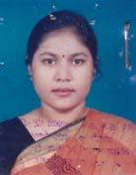 | DR. KHAIRUL OZAMA ISLAM NATASHA  F/Name: Nazrul Islam  M/Name: Rehana Islam  BM & DC Reg. No: 30442  NID: 2696402506347  Cell: 01715406955  Address: House # 14, Road # 06, Block # C, Mirpur-12, Dhaka-1216  Blood Group: O+
33 | Voter No  LM-4900033  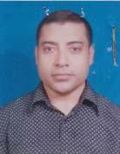 | DR. S. M. NURUL ABSAR  F/Name: Late. S.m. Nurul Huda  M/Name: Late, Meherunnessa  BM & DC Reg. No: 19174  NID: 2696402506348  Cell: 01819282459  Address: House # 14, Road # 06, Block # C, Mirpur-12, Dhaka- 1216  Blood Group: O+
34 | Voter No  LM-4900034  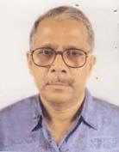 | DR. A. K. M. JAHANGIR CHOWDHURY  F/Name: Late Wahidur Rahman Chowdhury  M/Name: Late Rehena Begum  BM & DC Reg. No: 5714  NID:  Cell: 01711867845  Address: House # 1, IPH Officers Quarter, Mohakhali, Dhaka  Blood Group: B+
35 | Voter No  LM-4900035  No Image | DR. ANJAN SARKER  F/Name: Dr. Tarapada Sarker  M/Name:  BM & DC Reg. No:  NID:  Cell:  Address: Junior Consultant Pathology 250 Beded General Hospital, Noakhali.  Blood Group:
36 | Voter No  LM-4900036  No Image | DR. FAZLUL HOQUE KHAN  F/Name: Late Mr. Makbul Hoque Khan  M/Name:  BM & DC Reg. No: 751  NID:  Cell:  Address: N/A  Blood Group:
37 | Voter No  LM-4900037 | DR. KISHORE KUMAR HALDER  F/Name: Late Shatish Chandra Halder  M/Name:  BM & DC Reg. No:  NID:  Cell:  Address: Asstt. Prof. ENT.,  Noakhali Medical College  Noakhali,  Blood Group:
38 | Voter No  LM-4900038  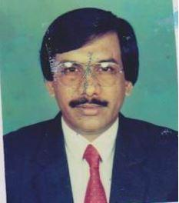 | DR. MALAY KANTI CHAKRABORTY  F/Name: Taraprashanta Chakraborty  M/Name:  BM & DC Reg. No:  NID:  Cell:  Address: Main Building 1st Floor,  Napiterpool,  Maijdee Court, Noakhali.  Blood Group:
39 | Voter No  LM-4900039  No Image | DR. ABDUL MANNAN SIDDIQUI  F/Name: Late Abdus Salam Siddiqui  M/Name:  BM & DC Reg. No:  NID:  Cell:  Address: 250, Beded General Hospital. Noakhali.  Blood Group:
40 | Voter No  LM-4900040  No Image | DR. DILARA ALO  F/Name: Late Delwar Hossain  M/Name:  BM & DC Reg. No:  NID:  Cell:  Address: Asstt. Professor (Newnatalogy)  Noakhali Medical College, Noakhali.  Blood Group:
41 | Voter No  LM-4900041  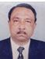 | DR. M. A NUMAN  F/Name: Md. Nurul Islam  M/Name: Late Nur Jahan Begum  BM & DC Reg. No: 8554  NID:  Cell:  Address: Dr, Numan Hospital Chatkhil Noakhali  Blood Group:
42 | Voter No  LM-4900042  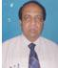 | DR. M. MOKLESUR RAHMAN  F/Name: Late M. Badiar Rahman  M/Name: Late Jobeda Khatun  BM & DC Reg. No: 277  NID:  Cell:  Address: Ramgonj Laxmipur Janajiban Medical.  Blood Group:
43 | Voter No  LM-4900043  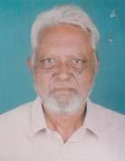 | DR. SALEH UDDIN MAHMOOD  F/Name: Late Mvi. Habib Ullah Khan  M/Name: Late. Sadia Begum  BM & DC Reg. No: 3407  NID: 7528704122765  Cell: 01829419904  Address: Housing Estate, Maijdee, Noakhali, H/no: 15, Rd. No. 30, Nur Mahal  Blood Group: B+
44 | Voter No  LM-4900044  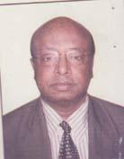 | DR. MD. NAZMUL ISLAM  F/Name: Md. Nurul Islam  M/Name: Noorjahan Khanam  BM & DC Reg. No: 6921  NID: 2693016089680  Cell: 01711549686  Address: Khonosthaye Nibash, 1/8 Hospital Road, Noakhali  Blood Group: A+
45 | Voter No  LM-4900045  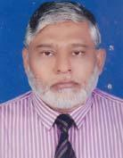 | DR. A. H. M. MOSLEM UDDIN  F/Name: Late Sultan Ahmed  M/Name: Late Fazilatonnessa  BM & DC Reg. No: 8156  NID: 7520703471174  Cell: 01711054949  Address: General Hospital, Noakhali  Blood Group: A+
46 | Voter No  LM-4900046  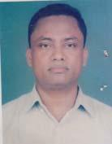 | DR. MD. MAHBUBUR RAHMAN  F/Name: Late Hazi Ali Ahmed  M/Name: Mrs. Fatema Begum  BM & DC Reg. No: 21407  NID: 7528704122759  Cell: 01713103467  Address: Md. Prime Hospital Ltd. Maijdee, Noakhali  Blood Group: B+
47 | Voter No  LM-4900047  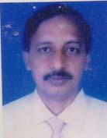 | DR. M. M. RAHMAN MD. MAHFUZUR RAHMAN  F/Name: G. M. Bhudiyan  M/Name: Mohochana Begum  BM & DC Reg. No: 12349  NID: 7528704123631  Cell: 01711738680  Address: 32/8 Housing Estats. Maijdee, Noakhali  Blood Group: A+
48 | Voter No  LM-4900048  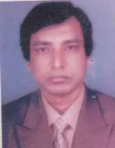 | DR. MD. SHAHER ALI  F/Name: Late Hekmat Ali Sarker  M/Name: Fatema Khatun  BM & DC Reg. No: 12323  NID: 7528704122914  Cell: 01711373272  Address: Prime Hospital Ltd. Maijdee Court, Noakhali  Blood Group: O+
49 | Voter No  LM-4900049 | DR. MOHAMMED NIZAM UDDIN  F/Name: Late Mohammad Rakib Ullah  M/Name: Late Tobaroker Nessa  BM & DC Reg. No: 21358  NID: 2691648035924  Cell: 01712230680  Address: Lacturer, Community Medicine, Noakhali Medical, College, Noakhali  Blood Group: B+
50 | Voter No  LM-4900050  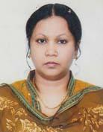 | DR. SALMA AHMED  F/Name: Prof. Dr. Shamsuddin Ahmed  M/Name: Motahera Begum  BM & DC Reg. No: 25002  NID: 2691649120494  Cell: 01711687316  Address: Flat A/2, House no- 78, Rd no- 9/A, Dhanmondi R/A, Dhaka-1209  Blood Group: A-
51 | Voter No  LM-4900051  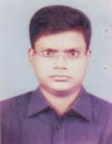 | DR. SUKHENDU SHEKHAR SEN  F/Name: Gopal Chandra Sen  M/Name: Rita Sen  BM & DC Reg. No: 32281  NID: 2696352207083  Cell: 01819158435  Address: Noakhali Medical College  Blood Group: B+
52 | Voter No  LM-4900052 | DR. HARI BHUSHAN SARKER  F/Name: Late Tulsi Naraya Sarker  M/Name: Labany Para Sarker  BM & DC Reg. No: A-29964  NID:  Cell:  Address: Medical Dept Noakhali Medical College, Noakhali  Blood Group:
53 | Voter No  LM-4900053  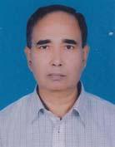 | DR. PRAFULLA CHANDRA NATH TALUKDER  F/Name: Late Atul Chandra Nath  M/Name: Nani Bala Debi  BM & DC Reg. No: 12411  NID: 7528702104689  Cell: 01712848657  Address: Astt. Professor- Cardiology, Noakhali Medical College  Blood Group: B+
54 | Voter No  LM-4900054  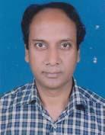 | DR. BAPPA GAUTAM  F/Name: Late H. Mondal  M/Name: Anima Chakravarty  BM & DC Reg. No: 22377  NID: 2695045916063  Cell: 01715165970  Address: Department of Biochemistry, Noakhali Medical College, Noakhali  Blood Group: O+
55 | Voter No  LM-4900055 | DR. MOHAMMAD IMAM HOSSAIN  F/Name: Monir Ahmed  M/Name: Zahanara Begum  BM & DC Reg. No: 40791  NID: 2696406674827  Cell: 01816281782  Address: C/O: 40 Hazi Azhar Ali Mia Bari, Vill: Alayerpur, P.O: West Alayerpur, Begumgonj, Noakhali  Blood Group: B+
56 | Voter No  LM-4900056  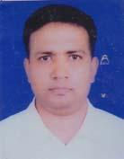 | DR. MASUD RANA  F/Name: Borhan Uddin Miah  M/Name: Nurun Nahar Begum  BM & DC Reg. No: 25978  NID: 2693014958509  Cell: 01914331574  Address: Noakhali Medical College, Noakhali  Blood Group:
57 | Voter No  LM-4900057  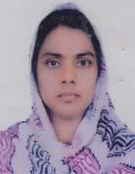 | DR. KAMRUN NAHAR  F/Name: Abu Bakr Siddique  M/Name: Mazida Begum  BM & DC Reg. No: 28129  NID: 1918163773864  Cell: 01818667586  Address: Shirat Mansion, House No-1, Road No: 4, Housing Society, Maijdee, Noakhali.  Blood Group: O+
58 | Voter No  LM-4900058  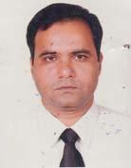 | DR. MIR HAMIDUR RAHMAN  F/Name: Mir Abdul Awal  M/Name: Mrs. Hamida Khatun  BM & DC Reg. No: 20569  NID:  Cell: 01712098223  Address: Consultant (Orthosurgery), 250 Beded, General Hospital, Noakhali  Blood Group: O+
59 | Voter No  LM-4900059 | DR. MD. SHAHADAT HOSSAIN  F/Name: Jamal Uddin Khan  M/Name: Mossammad Khaleda Khatun  BM & DC Reg. No: 23802  NID: 2693014960963  Cell: 01816095315  Address: Junior Consultant (Paed), Sonapur Upazilla Health Complex, Noakhali  Blood Group: A+
60 | Voter No  LM-4900060 | DR. NAZNIN RASHID SHEWLY  F/Name: Abdur Rashid Khan  M/Name: Begum Nur Jahan Rashid `  BM & DC Reg. No: 26424  NID:  Cell:  Address: Noakhali Medical College  Noakhali  Blood Group:
61 | Voter No  LM-4900061  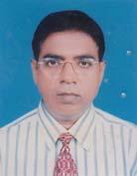 | DR. MD. MOJIBUL HAQUE  F/Name: Mr. Abdul Haque  M/Name: Late Rokoner Nessa  BM & DC Reg. No: 17514  NID: 28704123424  Cell: 01726415270  Address: Asstt. Prof. (Ent) Noakhali Medical College, Noakhali  Blood Group: A+
62 | Voter No  LM-4900062 | DR. A. S. M. WALI ULLAH  F/Name: Nur Mohammad  M/Name: Ayesha Begum  BM & DC Reg. No: 26672  NID: 2694812051017  Cell: 01711487061  Address: Assit. Professor Dept. of Neonatology, Noakhali Medical College Noakhali  Blood Group: B+
63 | Voter No  LM-4900063 | DR. ABDULLAH AL MAHMOOD BILAL  F/Name: Late Ali Akbar  M/Name: Late Masuma Khatun  BM & DC Reg. No: 22785  NID: 2691648034507  Cell: 01712286044  Address: Noakhali Medical College, Noakhali  Blood Group: B+
64 | Voter No  LM-4900064  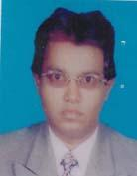 | DR. BABUL AHMED  F/Name: Late. Abdur Rahman  M/Name: Late. Sobura Khatun  BM & DC Reg. No: 27573  NID: 2696405645365  Cell: 01737605395  Address: Padma Building, Senior Consultant Quarter, 250 Bed General Hospital Noakhali  Blood Group: A-
65 | Voter No  LM-4900065 | DR. PARTHA SARATHY MAJUMDER  F/Name: Milon Kumar Majumder  M/Name: Nripati Majumder  BM & DC Reg. No: 30912  NID:  Cell: 01712196254  Address: R. S. ( Resident Surgeon), 250- Beded General Hospital, Noakhali  Blood Group: O+
66 | Voter No  LM-4900066  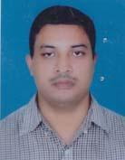 | DR. KARNAJIT MAJUMDER  F/Name: Pankaj Chandra Majumder  M/Name: Bhanu Moti Majumder  BM & DC Reg. No: 23466  NID:  Cell: 01716710767  Address: Phanthanir, 1st Floor, Hospital Road, Maijdee, Noakhali  Blood Group: O+
67 | Voter No  LM-4900067 | DR. MD. NURUZZAMAN SABUZ  F/Name: Md. Abdul Matin  M/Name: Mrs. Nur Nahar Begum  BM & DC Reg. No: 49288  NID: 1926718126498  Cell: 01818551322  Address: Lecturer, Departmen of Pathology, Noakhali Medical College  Blood Group: O+
68 | Voter No  LM-4900068  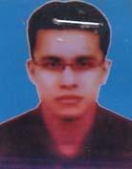 | DR. S.M. AMANAT ULLAH  F/Name: A.k.m. Nizam Uddin  M/Name: Mamata Begum  BM & DC Reg. No: 51118  NID: 1594122969831  Cell: 01714311226  Address: Road no 4635 G/1 (House no), Fayi Lake, Khulshi, Lake Valley, Chittagong, Noakhali Medical College  Blood Group: O+
69 | Voter No  LM-4900069  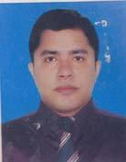 | DR. MD. JAHEDUL ISLAM  F/Name: Md. Wazi Ullah  M/Name: Khatun-e-jannath  BM & DC Reg. No: 48696  NID: 9196209210116  Cell: 01673774974  Address: Bishal Centre, Main Road, Maijdee Court, Noakhali  Blood Group: B+
70 | Voter No  LM-4900070  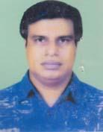 | DR. MD. SAIFUL ISLAM  F/Name: Late- Md. Shafiul Hoque  M/Name: Mrs. Rezia Begum  BM & DC Reg. No: 23981  NID:  Cell: 01713366163  Address: 250 Bed General Hospital, Noakhali  Blood Group: B+
71 | Voter No  LM-4900071  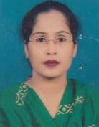 | DR. MST. FARHANA TARANNUM KHAN  F/Name: Late Abdur Rahman Khan  M/Name: Hena Khan  BM & DC Reg. No: 29068  NID: 2691650161869  Cell: 01711969950  Address: 194/A, Rasel Manjil, Hospital Road, (Near Janani Hospital), Maijdee, Noakhali  Blood Group: A+
72 | Voter No  LM-4900072  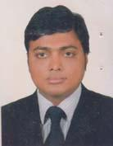 | DR. KHANDAKER SHAHEEN HOSSAIN  F/Name: Md. Nazirullah Khandaker  M/Name: Late. Monoara Begum  BM & DC Reg. No: 32316  NID: 2697556418142  Cell: 01715112970  Address: Soleman Cottage (2nd floor, North Side), Road-18, Holding no-1353, Housing Estate, Maijdee, Noakhali  Blood Group: O+
73 | Voter No  LM-4900073  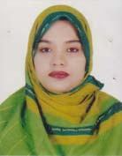 | DR. FOZILATUN NESA  F/Name: A.j.m Shahidullah  M/Name: Nurjahan Begum  BM & DC Reg. No: 53726  NID: 2694810985380  Cell: 01615839132  Address: Soleman Cottage (2nd floor, North Side), Road-18, Holding no-1353, Housing Estate, Maijdee, Noakhali  Blood Group: A+
74 | Voter No  LM-4900074 | DR. MOHAMMAD FAIZ AHMAD KHANDOKER  F/Name: Md. Momin Ullah Khandoker  M/Name: Mahinur Begum  BM & DC Reg. No: 30862  NID: 1594116382420  Cell: 01711571879  Address: Khandoker Bari, Khandoker Nagar, Maijdee, Noakhali  Blood Group: O+
75 | Voter No  LM-4900075  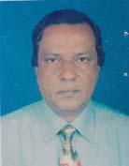 | DR. MD. ABUL KASHEM  F/Name: Late Md. Hormuz Meah  M/Name: Saleha Khatun  BM & DC Reg. No: 12504  NID: 1718780263434  Cell: 01713113234  Address: 250 Beded Noakhali General Hospital.  Blood Group:
76 | Voter No  LM-4900076  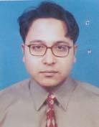 | DR. MOHAMMAD MAMOON ISLAM  F/Name: Harunur Rashid Mazumder  M/Name: Mrs. Rokeya Harun  BM & DC Reg. No: 40625  NID: 2698877383238  Cell: 01717158401  Address: 250 Beded General Hospital, Maijdee, Noakhali.  Blood Group: B+
77 | Voter No  LM-4900077  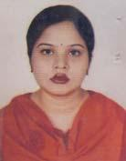 | DR. NUSRAT IMAM SUNNY  F/Name: Imam Sharif  M/Name: Yasmin Sharif  BM & DC Reg. No: 43541  NID: 2698877383237  Cell: 01711051518  Address: 250 Beded General Hospital, Noakhali  Blood Group:
78 | Voter No  LM-4900078  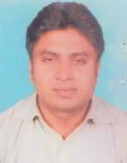 | DR. MD. MAHBUBUR RAHMAN  F/Name: Late. Md. Toaha Mia  M/Name: Rowshan Ara Begum  BM & DC Reg. No: 47301  NID:  Cell: 01712071701  Address: Assistant Register (Medicine) 250 Beded General Hospital, Noakhali  Blood Group: B+
79 | Voter No  LM-4900079 | DR. MOHAMMAD NURUL ALAM  F/Name: Alhaj A B M Abdul Majid  M/Name: Late Fakhrun Nahar  BM & DC Reg. No: 40091  NID: 7518359437033  Cell: 01711448739  Address: FPAB Shaheed Mesbah Uddin Sarak Uzzalpur, Maijdee Court, Noakhali  Blood Group: B+
80 | Voter No  LM-4900080  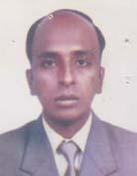 | DR. FAZLA ALAHI KHAN  F/Name: Mr. Ayub Ali Khan  M/Name: Mrs. Ferdous Ara  BM & DC Reg. No: 31775  NID:  Cell: 01711356941  Address: Sherni- Mension- Board School Road, Maijdee, Noakhali  Blood Group: O+
81 | Voter No  LM-4900081 | DR.MD.MAINUDDIN AL MASOOD  F/Name: Md. Shafiq Ullah  M/Name: Mrs. Tahmina Shafiq  BM & DC Reg. No: 45294  NID: 2698878417812  Cell: 01716601101  Address: House No.11,Artillery Road,New I Block,Halishahar Housing Estate,Halishahar,Chattogram.  Blood Group: B+
82 | Voter No  LM-4900082  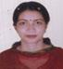 | DR. EAMAT ARA PARVIN  F/Name: Late Kazi A. K. M Anwar Ullah  M/Name: Late Kohinur Akter  BM & DC Reg. No: 50239  NID:  Cell:  Address: Address: Nur Moltol T.N.O. House Stchia Road Di - Noakhali  Blood Group:
83 | Voter No  LM-4900083  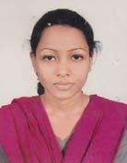 | DR. ISRAT JAHAN  F/Name: Md. Jamal Uddin  M/Name: Khodeza Begum  BM & DC Reg. No: 54100  NID: 2697688495707  Cell: 01711528626  Address: Vill- Alipur, P.O.- Companir Hat, P.S.- Kabir Hat, Dist.- Noakhali  Blood Group: O+
84 | Voter No  LM-4900084 | DR. MOHAMMAD MOHI UDDIN  F/Name: Md. Elias Mash  M/Name: Mrs Moriemer Nessa  BM & DC Reg. No: 28594  NID:  Cell:  Address: Address: Vill- East Laxminjrpur Po- Majumder Cout Ps- Sadar Dist- Noakhali  Blood Group:
85 | Voter No  LM-4900085 | DR. MOHAMMAD ARAFAT RAHMAN  F/Name: Mohammad Shahidur Rahman  M/Name: Gulshan Ara Begum  BM & DC Reg. No: 44552  NID: 7528705133617  Cell: 01925476993  Address: Al-Amin House, Law Year's Colony, Maijdee Court, Noakhali  Blood Group: O+
86 | Voter No  LM-4900086  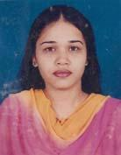 | DR. FERDOUSI AKTER  F/Name: M. Nurul Amin  M/Name: Bilkis Ara  BM & DC Reg. No: 50599  NID:  Cell: 01733633495  Address: 197, North Shahjahanpur, Dhaka-1217  Blood Group:
87 | Voter No  LM-4900087  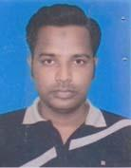 | DR. MOHAMMAD IBRAHIM KHALIL  F/Name: Mohammad Momin Ullah  M/Name: Fatema Bilkis  BM & DC Reg. No: 45060  NID:  Cell: 01732173687  Address: Vill: Eojbalia, P.O: Shantasheta Sadar, Noakhali  Blood Group: A+
88 | Voter No  LM-4900088 | DR. S.M.A. JAFRE  F/Name: Shah Akbar  M/Name: Aridun Nahar Laily M.p.  BM & DC Reg. No: 49045  NID: 2695042781806  Cell: 01612389734  Address: Shantinikatan, 29/203 Babor Road, Block-F, Mohammadpur, Dhaka-1207  Blood Group: O+
89 | Voter No  LM-4900089 | DR. NAEEB WAHED  F/Name: Abu Taher  M/Name: Late Nilufar Sultana  BM & DC Reg. No: 48428  NID: 1594116722112  Cell: 01674915506  Address: 118, New Eskaton, Dhaka-1217 .  Blood Group: O+
90 | Voter No  LM-4900090  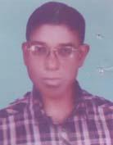 | DR. BHAKTI RANJAN PAUL  F/Name: Late Nikunja Bihari Paul  M/Name: Late Anonto Bala Paul  BM & DC Reg. No: 9995  NID: 7518760238810  Cell: 01717300511  Address: Paul Chowdhury Bari, Fatehpur Sadar, Noakhali  Blood Group: O+
91 | Voter No  LM-4900091  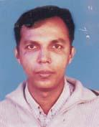 | DR. ABUL HASNAT MOHAMMAD REZAUL HOSSAIN  F/Name: Hoosain Ahmed  M/Name: Mrs. Nune Ara  BM & DC Reg. No: 31160  NID:  Cell: 01716894097  Address: Chairman Niramoy Hospital (PVT), Maijdee, Noakhali  Blood Group: B+
92 | Voter No  LM-4900092  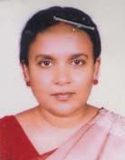 | DR. LUTFAN NESSA  F/Name: Md. Lutfor Rahman  M/Name: Mrs. Mahmuda Rahman  BM & DC Reg. No: 22105  NID:  Cell: 01718174751  Address: Asstt. Prof (Paed) NMCH,Noakhali.  Blood Group: O+
93 | Voter No  LM-4900093  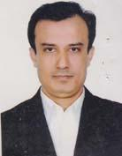 | DR. MD. MAMINUL ISLAM  F/Name: Md. Abu Sayeed  M/Name: Mrs. Fatema Begum  BM & DC Reg. No: 26100  NID: 2222410360377  Cell: 01819611678  Address: Holding House No 30, Ceatacl Road House -110 Estate, Maijdecourt, Noakhali.  Blood Group: B+
94 | Voter No  LM-4900094  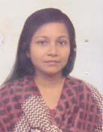 | DR. NUSRAT SHAHEED  F/Name: Late. H. M Shaheedullah Chy  M/Name: Late. Lutfunnahar Chy  BM & DC Reg. No: 37365  NID:  Cell: 01816373167  Address: Bijoy Bhaban, Govt. Womens College Road, Maijdee, Noakhali  Blood Group: O+
95 | Voter No  LM-4900095  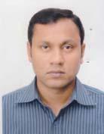 | DR. MOHAMMAD MIZANUR RAHMAN  F/Name: Md. Nurul Islam  M/Name: Mrs. Rezia Begum  BM & DC Reg. No: 43664  NID: 5117323524710  Cell: 01713304751  Address: Jahanara Monjil, Road: 04, Ward: 04, Fakirpur, Maijdeecourt, Noakhali  Blood Group: O+
96 | Voter No  LM-4900096  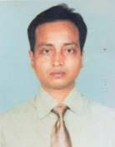 | DR. MD. ENAMUL KARIM  F/Name: Md. Abdul Mabud  M/Name: Afroza Khatun  BM & DC Reg. No: 23653  NID:  Cell: 01817382766  Address: 2A Central Six, 20 Central Road, Housing Estate, Maijdee, Noakhali 3800  Blood Group:
97 | Voter No  LM-4900097 | DR. SHAKER UDDIN AHMED  F/Name: Late. Saleh Uddin Ahmed  M/Name: Mrs. Kamrun Nesa  BM & DC Reg. No: 23680  NID: 2617283734791  Cell: 01713081607  Address: Central Road, Luxmi Jarayanpur, Maizdee Court, Sadar, Noakhali  Blood Group: B+
98 | Voter No  LM-4900098  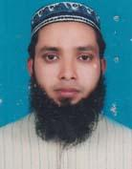 | DR MD GIAS UDDIN  F/Name: Mr. Sheikh Ahmed  M/Name: Mrs. Aleya Begum  BM & DC Reg. No: 48880  NID: 7518047917995  Cell: 01912442533  Address: Junior Consultant (Paediatrics) Senbag, Noakhali.  Blood Group: A+
99 | Voter No  LM-4900099 | DR. MD. ASADUL HAQUE KHAN  F/Name: Late. Joynal Haque Khan  M/Name: Umme Mohesena Khatun  BM & DC Reg. No: 24794  NID: 7528704122588  Cell: 01711104767  Address: General Hospital, Maijdee, Noakhali  Blood Group: A+
100 | Voter No  LM-4900100 | DR. MD. MABUL HASHEM  F/Name: Md. Eshaq Miah  M/Name: Anwara Begum  BM & DC Reg. No: 24990  NID:  Cell: 01720173475  Address: Upazila Health Complex, Companygonj, Noakhali  Blood Group:
101 | Voter No  LM-4900101  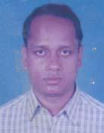 | DR. A. N. MANIRUZZAMAN  F/Name: Md. Nurezzaman  M/Name: Basura Khatun  BM & DC Reg. No: 26169  NID:  Cell: 01712121125  Address: Upazilla Health Complex, Subornachar, Noakhali  Blood Group: O+
102 | Voter No  LM-4900102  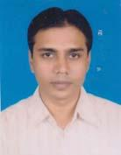 | DR. ZAHIR UDDIN  F/Name: Mohammad Ali  M/Name: Dil Newaj  BM & DC Reg. No: 36918  NID: 7512123129222  Cell: 01712913830  Address: Medinova Medical Centre, Hospital Road, Basurhat, Companigonj, Noakhali  Blood Group: B+
103 | Voter No  LM-4900103  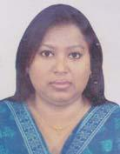 | DR. LABONI ROY  F/Name: Dr. Gouranga Chandra Roy  M/Name: Prova Roy  BM & DC Reg. No: 45982  NID: 1594115406371  Cell: 01716574666  Address: Hoque Manjil, Hospital Road, Basurhat Pouroshova, Companygonj, Noakhali  Blood Group: B+
104 | Voter No  LM-4900104  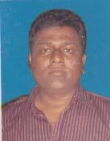 | DR. AJOY MAJUMDER  F/Name: Madan Mohan Majumder  M/Name: Renu Majumder  BM & DC Reg. No: 366531  NID: 1594115406370  Cell: 01711121987  Address: Hoque Manjil, Hospital Road, Basurhat Pouroshova, Companygonj, Noakhali  Blood Group: O+
105 | Voter No  LM-4900105  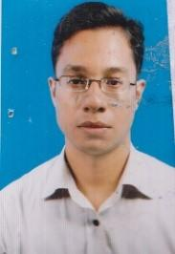 | DR. ABDULLAH ALL MORSHED  F/Name: Md. Imdadul Haque  M/Name: Late. Sazeda Haque  BM & DC Reg. No: 44535  NID: 7522103067303  Cell: 01716992481  Address: Habibur Rahman Moktar Bari, Vill: Karalia, Basurhat, Companygonj, Noakhali  Blood Group: B+
106 | Voter No  LM-4900106  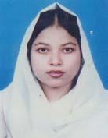 | DR. MAKSUDA SULTANA  F/Name: Mohammad Abdul Halim  M/Name: Sultana Razia  BM & DC Reg. No: 41212  NID: 8524904106234  Cell: 01191523366  Address: Halim Monjil, Hospital Road, Daganbhuiyan, Feni  Blood Group: O+
107 | Voter No  LM-4900107 | DR. MRINAL SAHA  F/Name: Babu Chuni Lal Saha  M/Name: Kalpana Saha  BM & DC Reg. No: 46660  NID: 269754757395458  Cell: 01712173226  Address: MO, Companigonj UPZ. H. Complex Noakhali  Blood Group: A+
108 | Voter No  LM-4900108  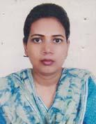 | DR. MINHAJ JAHAN  F/Name: Shajahan Bhuiyan  M/Name: Momtajara Begum  BM & DC Reg. No: 42280  NID: 2693622302270  Cell: 01749094774  Address: UHC, Companygonj, Noakhali  Blood Group: B+
109 | Voter No  LM-4900109 | DR. RSSHIDUL HASAN  F/Name: Harun Or Rashid  M/Name: Nigar Sultana  BM & DC Reg. No: 39434  NID:  Cell:  Address: Address: Uhc - Companigong  Noakhali  Blood Group:
110 | Voter No  LM-4900110 | DR. MD. RASHEDUL ISLAM  F/Name: Md. Rofiqul Islam  M/Name: Khadiza Begum  BM & DC Reg. No: 37236  NID:  Cell: 01670467287  Address: Address: Medical Officer Companigong Helth Complex Noakhali  Blood Group:
111 | Voter No  LM-4900111  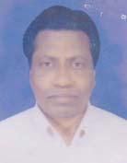 | DR. MD. SHAFIQUL ISLAM  F/Name: Mokhlesur Rahman  M/Name: Mrs. Amena  BM & DC Reg. No: 17711  NID: 2693004782466  Cell: 01824713201  Address: UH&FPO, Kabihat, Noakhali  Blood Group: B-
112 | Voter No  LM-4900112  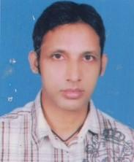 | DR. MINTU KANTI DAS  F/Name: Ajoy Kanti Das  M/Name: Dipali Rani Das  BM & DC Reg. No: 52771  NID: 8524904043218  Cell: 01717277758  Address: Nova CT Scan, 1st Floor, Maijdee, Noakhali  Blood Group: A+
113 | Voter No  LM-4900113 | DR. FAZLUL HAQ BAKER  F/Name: Md. Anwarul Azim  M/Name: Aftaber Naher  BM & DC Reg. No: 47219  NID: 2690243834993  Cell: 01818839625  Address: MO, Kabirhat, Noakhali  Blood Group: O+
114 | Voter No  LM-4900114  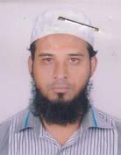 | DR. MINHAJUL ABSAR  F/Name: Md. Nurul Absar  M/Name: Mrs. Monjuara Begum  BM & DC Reg. No: 49903  NID:  Cell: 01818425148  Address: Abdullah Miar Bari, Purbo Rejungaon, Kobirhat, Noakhali  Blood Group: B+
115 | Voter No  LM-4900115 | DR. MOHAMMAD MIZANUR RAHMAN  F/Name: Mohammad Abdul Halim  M/Name: Late Begum Hosne Ara  BM & DC Reg. No: 28156  NID:  Cell:  Address: Address: RMO Chanalsi Hasnlas  Noakhali - 1254  Blood Group:
116 | Voter No  LM-4900116  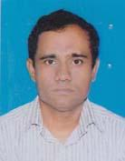 | DR. SWAPAN DAS  F/Name: Late. Harinath Das  M/Name: Mrs. Laxmi Bala Das  BM & DC Reg. No: 27027  NID: 7528704121429  Cell: 01715008919  Address: Medical Officer, 20 Beded Char Algi Hospital, Kabirhat, Noakhali  Blood Group: A+
117 | Voter No  LM-4900117 | DR. MOHAMMAD IMRUL HASAN  F/Name: Mohammad Abul Hossain  M/Name: Rahima Akhter  BM & DC Reg. No: 45397  NID:  Cell:  Address: Address: Medical Offcer Upazila Helth Complex Subarnachar Noakhali  Blood Group: A+
118 | Voter No  LM-4900118  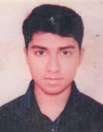 | DR. JOYBAER ANAM CHOWDHURY  F/Name: Khairul Anam Salim  M/Name: Dilara Selim  BM & DC Reg. No: 45881  NID:  Cell: 01673137747  Address: Vill: Sonapur, PO: Sonapur, Upazilla: Sadar, Dist: Noakhali  Blood Group: B+
119 | Voter No  LM-4900119 | DR. SOYED MOHIUDDIN ABDUL AZIM  F/Name: Late. Abdus Samad  M/Name: Marium Banu  BM & DC Reg. No: 47927  NID:  Cell: 01727471745  Address: Medical Officer, Upazilla Health Complex, Subarnachar, Noakhali  Blood Group: B+
120 | Voter No  LM-4900120  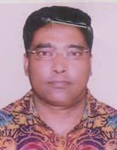 | DR. PIJUSH KANTI NATH  F/Name: Late. Murari Mohan Nath  M/Name: Late. Kamini Bala Devi  BM & DC Reg. No: 17374  NID: 7520706492674  Cell: 01711726877  Address: 07, Public Hall Road, Chaumuhani, Noakhali, Bangladesh  Blood Group: O+
121 | Voter No  LM-4900121  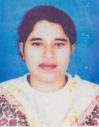 | DR. KAOSER JAHAN  F/Name: Late. Abu Abdullah  M/Name: Razia Abdullah  BM & DC Reg. No: 30928  NID: 2699039595721  Cell: 01718339899  Address: Hospital, Choumuhani, Noakhali  Blood Group: A+
122 | Voter No  LM-4900122 | DR. MD. ABUL KASHEM  F/Name: Md. Ali Akkas  M/Name: Mrs. Tahera Khatun  BM & DC Reg. No: 25944  NID: 2699039663943  Cell: 01817052820  Address: C-3, Rosana, 25 North Dhanmondi, Dhaka-1205  Blood Group: A+
123 | Voter No  LM-4900123  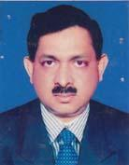 | DR. MD. SHAHABUDDIN  F/Name: Late. Dr. Shamsuddin Ahmed Chowdhury  M/Name: Mosfeka Begum  BM & DC Reg. No: 12909  NID: 7520706494535  Cell: 01712271836  Address: Nabila General Hospital, College Road, Chaumohoni, Noakhali  Blood Group: A+
124 | Voter No  LM-4900124  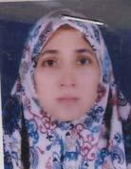 | DR. HASINA BEGUM  F/Name: A. M. Nuruddin  M/Name: Meherun Nesa  BM & DC Reg. No: 16949  NID: 7520706492930  Cell: 01711425554  Address: Nabila General Hospital, College Road, Chaumohoni, Noakhali  Blood Group: B+
125 | Voter No  LM-4900125 | DR. MOHAMMAD ALAUDDIN  F/Name: Late. Mohammad Abul Kalam  M/Name: Late. Aceya Khatun  BM & DC Reg. No: 26939  NID: 2692984615684  Cell: 01710876844  Address: Upazilla Health Complex, Begumgonj, Noakhali  Blood Group: O+
126 | Voter No  LM-4900126  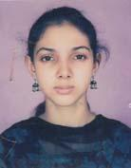 | DR. SHABRINA ANWAR  F/Name:  M/Name:  BM & DC Reg. No: 57712  NID: 2698878295021  Cell:  Address: C/O: Dr. Chowdhury Forhadul Karim, Vill: Bhaba Bhadri, PO: Chandrogonj, Upazilla: Begumgonj, Dist: Noakhali  Blood Group: AB_po  TRANSFERED to BMA Dhaka City  LM-1405543
127 | Voter No  LM-4900127  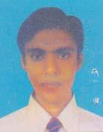 | DR. CHOWDHURY FORHADUL KARIM  F/Name:  M/Name:  BM & DC Reg. No: 51913  NID: 2696655334022  Cell:  Address: C/O: Dr. A. N. M. Shamsul Kariam, Vill: Bhaba Badri, PO: Chandrogonj, Upazilla: Begumgonj, Dist: Noakhali  Blood Group: B+  TRANSFERED to BMA Dhaka City  LM-1405543
128 | Voter No  LM-4900128  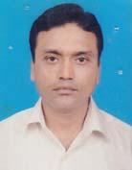 | DR. MOHAMMAD DELWAR HOSSAIN  F/Name: Late. Mohammad Safi Ulla  M/Name: Late. Fatema Begum  BM & DC Reg. No: 36346  NID: 1594308369317  Cell: 01684210134  Address: Hospital, Chaumohoni, Noakhali  Blood Group: B+
129 | Voter No  LM-4900129  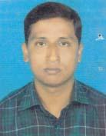 | DR. MOHAMMAD ATA ULLAH  F/Name: Mohammad Saidul Haque  M/Name: Dallari Begum  BM & DC Reg. No: 38202  NID:  Cell: 01714389045  Address: House-1/A, R-10, Sector-14, Uttara Dhaka, Resident Dept Cardiac Surgery, BSMMU  Blood Group:
130 | Voter No  LM-4900130  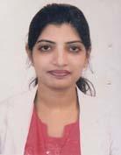 | DR. SHAHANARA AKTER  F/Name: Late. Md. Abdul Latif  M/Name: Begum Shafiqunnahar  BM & DC Reg. No: 47286  NID:  Cell: 01717788172  Address: Medical Officer (Gynae & Obs), 250 Bed General Hospital, Noakhali  Blood Group: B+
131 | Voter No  LM-4900131  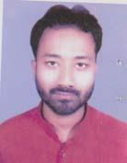 | DR. MOHAMMAD MONIR HOSSAIN  F/Name: Md. Khalil Ullah  M/Name: Mrs. Nurjahan Begum  BM & DC Reg. No: 52705  NID: 2697683275117  Cell: 01714423810  Address: Vill: Narattampur, PO: Pandit Bazer, Thana: Begumganj, Dist: Noakhali  Blood Group: O+
132 | Voter No  LM-4900132 | DR. ASIM KUMAR DAS  F/Name: Birendra Kishor Das  M/Name: Rama Rani Das  BM & DC Reg. No: 47076  NID: 7518313499358  Cell: 01913099866  Address: Vill & PO: Amber Nagar, PS: Sonaimuri, Dist: Noakhali  Blood Group: O+
133 | Voter No  LM-4900133  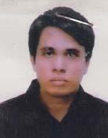 | DR. A. F. M. AMINUL ISLAM  F/Name: Md. Abul Kalam  M/Name: Momotaz Begum  BM & DC Reg. No: 45288  NID: 7520703471884  Cell: 01712-627285  Address: Puraton Kazir Basa, Alipur (Kuripara), Begumganj, Noakhali  Blood Group:
134 | Voter No  LM-4900134  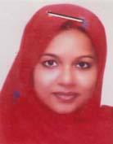 | DR. FARJANA RAHMAN  F/Name: Md. Zafar Ullah  M/Name: Rowshan Ara Begum  BM & DC Reg. No: 50992  NID: 2696654361622  Cell: 01712296020  Address: House: 1, Road: 28, Housing Estate, Maijdee Court, Noakhali  Blood Group: O+
135 | Voter No  LM-4900135  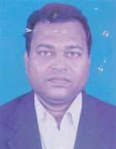 | DR. MD. MONJURUL HAQUE  F/Name: Late. Md. Tofazzal Hossain  M/Name: Mrs. Monu Ara Begum  BM & DC Reg. No: 22957  NID: 7522108076769  Cell: 01715147338  Address: Basurhat Pvt. Hospital Unit-2, Hospital Road, Compnaygonj, Noakhali  Blood Group: A+
136 | Voter No  LM-4900136  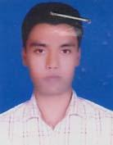 | DR. MD. MASUDUR RAHMAN  F/Name: Ali Azzam  M/Name: Mrs. Momotaj Begum  BM & DC Reg. No: 44520  NID: 7510756558229  Cell: 01824810474  Address: Vill: Dorappur, PO: Babupur, PS: Begumganj, Noakhali  Blood Group: O+
137 | Voter No  LM-4900137  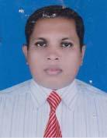 | DR. BENU LAL BANIK  F/Name: Bijoy Kumar Banik  M/Name: Anjali Banik  BM & DC Reg. No: 38782  NID:  Cell: 01711660582  Address: Kibria Bhaban, Gazipara, Main Road, Sadar, Maijdee, Noakhali  Blood Group: A+
138 | Voter No  LM-4900138  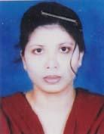 | DR. SALMA SULTANA  F/Name: Muhammad Humaun Kabir  M/Name: Mrs. Atika Kabir  BM & DC Reg. No: 41678  NID: 2694810959445  Cell: 01712526854  Address: Mohesigonj, North Colony Chaumohoni, Begumganj  Blood Group: B+
139 | Voter No  LM-4900139  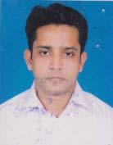 | DR. MD. KAMAL UDDIN SOHEL  F/Name: Md. Amanat Ullah  M/Name: Setara Begum  BM & DC Reg. No: 41153  NID: 2697557395264  Cell: 01716074769  Address: Ali Bhaban Karimpur Road, Chowmohony, Noakhali  Blood Group: B+
140 | Voter No  LM-4900140  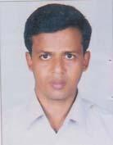 | DR. ANUPAM MAJUMDER  F/Name: Rebati Mohan Majumder  M/Name: Shoibalani Majumder  BM & DC Reg. No: 40932  NID: 512806412392  Cell: 01716385063  Address: C/O: Lab Aid Medical Centre, Sonaimuri, Noakhali  Blood Group: B+
141 | Voter No  LM-4900141  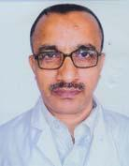 | DR. MD. MOINUL HASAN  F/Name: Late. Sayed Md. Shafiullah  M/Name: Late. Suprity Shafi  BM & DC Reg. No: 15876  NID:  Cell: 01711422385  Address: Medical Officer, Upazilla Health Complex, Sonaimuri, Noakhali  Blood Group: B+
142 | Voter No  LM-4900142  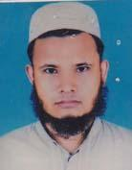 | DR. MD. NURUL ISLAM  F/Name: Serajul Islam  M/Name: Ayesha Seraj  BM & DC Reg. No: 41251  NID:  Cell: 0181604809  Address: Indoor Medical Officer, Upazilla Health Complex, Sonaimuri, Noakhali  Blood Group: O+
143 | Voter No  LM-4900143  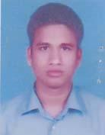 | DR. MUHAMMAD MORSHEDUR RAHMAN  F/Name: Muhammad Ayub Ullah Khan  M/Name: Moriomer Nesa  BM & DC Reg. No: 47247  NID: 2690243026690  Cell: 01921879121  Address: H-23, R-11, S-13, Uttara, Dhaka-1230/UHC, Sonaimuri, Noakhali  Blood Group: A+
144 | Voter No  LM-4900144  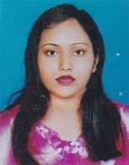 | DR. SHARMIN NIGAD SHARNA  F/Name: Late. Md. Abu Taher  M/Name: Laila Nargish  BM & DC Reg. No: 52957  NID:  Cell: 01731291140  Address: MO, UHC, Sonaimuri, Noakhali  Blood Group: B+
145 | Voter No  LM-4900145 | DR. MD. ABU TAHER  F/Name: Hazi Mohammad Ullah  M/Name: Tahmina Begum  BM & DC Reg. No: 51321  NID:  Cell: 01712530254  Address: N.S Tower (5th Floor), Karimpur Road, Chaumohoni, Noakhali  Blood Group: B+
146 | Voter No  LM-4900146 | DR. K.M SAIFULLAH  F/Name: Late. Prof. A.k.m Abdullah  M/Name: Del Afrose Begum  BM & DC Reg. No: 47324  NID: 2696654324621  Cell: 01722099075  Address: Upazilla Health Complex, Senbag, Noakhali (MO)  Blood Group: B+
147 | Voter No  LM-4900147  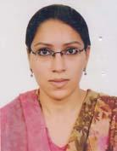 | DR. RUMANA PARVEEN  F/Name: Masood Hadi Raza  M/Name: Nazrana Akhter  BM & DC Reg. No: 47325  NID:  Cell: 01711158548  Address: Upazilla Health Complex (MO), Senbag, Noakhali  Blood Group: O+
148 | Voter No  LM-4900148  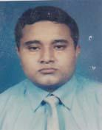 | DR. MD. NAZRUL ISLAM  F/Name: Md. Abdul Malek  M/Name: Qumeara Begum  BM & DC Reg. No: 51365  NID: 2696406683215  Cell: 01912163445  Address: Senbag Upazilla Health Complex, Senbag, Noakhali  Blood Group: O+
149 | Voter No  LM-4900149  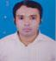 | DR. MD. SHAKHAWAT HOSSAIN  F/Name: A. K. M Ferdous  M/Name: Jebun Nahar  BM & DC Reg. No: 47942  NID:  Cell:  Address: BMDC Reg. No: A47942  Address: Upazilla Helth Complex Senbag Noakhali  Blood Group:
150 | Voter No  LM-4900150  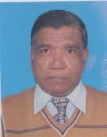 | DR. KARTIC CHANDRA DAS  F/Name: Bhabatosh Das  M/Name: Late. Dija Moni Rani Das  BM & DC Reg. No: 12772  NID: 7521006628288  Cell: 01725052959  Address: Hospital Quarter, Chatkhil, Noakhali  Blood Group: B+
151 | Voter No  LM-4900151  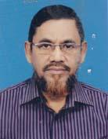 | DR. MD. KHALIL ULLAH  F/Name: Haji. Md. Sekander Ali  M/Name: Ayesa Begum  BM & DC Reg. No: 15125  NID: 7521002618004  Cell: 01711423341  Address: UH&FPO, Upazilla Health Complex, Chatkhil, Noakhali  Blood Group: B+
152 | Voter No  LM-4900152  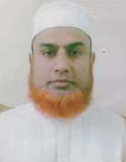 | DR. MOHD. SHAHADAT HOSSAIN RATAN  F/Name: Late. Mohd. Belayet Hossain  M/Name: Mrs. Zahera Begum  BM & DC Reg. No: 17103  NID: 7521006629141  Cell:  Address: Chatkhil Sisu Hospital (Pvt.), Palla Road, Noakhali  Blood Group: A+
153 | Voter No  LM-4900153  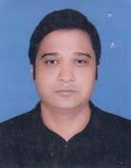 | DR. MOHAMMAD OBAIDUL HAQUE  F/Name: Late. Monwarul Haque  M/Name: Mrs. Fauzia Haque  BM & DC Reg. No: 50373  NID:  Cell: 01710927346  Address: Chatkhil Central Hospital  Blood Group: O+
154 | Voter No  LM-4900154  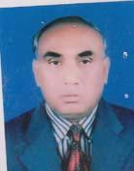 | DR. GOUR CHANDRA BANIK  F/Name: Late. Karuna Kumar Banik  M/Name: Late. Manda Sundari Banik  BM & DC Reg. No: 7706  NID: 5126503865298  Cell: 01711725101  Address: Vill: Ratanpur, Ward: 03, Ramgonj Pouropara, PO & UZ: Ramgonj, Dist: Laksmipur  Blood Group: A+
155 | Voter No  LM-4900155  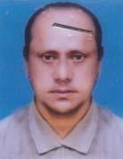 | DR. MOHAMMED ALI  F/Name: Late. Hamid Ullah  M/Name: Sakina Begum  BM & DC Reg. No: 16311  NID: 7511076659534  Cell: 01712673361  Address: PO: Molliker Dighir Par, UZ: Chatkhil, Noakhali  Blood Group: O+
156 | Voter No  LM-4900156  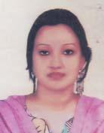 | DR. FARHANA NOMAN  F/Name: Dr. M. A. Numan  M/Name: Mrs. Jarina Numan  BM & DC Reg. No: 50080  NID: 07521007632365  Cell: 01816393089  Address: Dr. Numan Hospital, Chatkhil, Noakhali  Blood Group:
157 | Voter No  LM-4900157  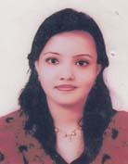 | DR. FARZANA NUMAN  F/Name: Dr. M. A. Numan  M/Name: Mrs. Jarina Numan  BM & DC Reg. No: 45274  NID: 7521007631673  Cell: 01818714101  Address: Dr. Numan Hospital, Chatkhil, Noakhali  Blood Group: B+
158 | Voter No  LM-4900158 | DR. MOHAMMAD MUNIR HOSSAIN  F/Name: Md. Khurshid Alam  M/Name: Mrs. Sujia Begum  BM & DC Reg. No: 34891  NID: 2690815049254  Cell: 01712039139  Address: Dosgoric, Chatkhil, Noakhali  Blood Group: O+
159 | Voter No  LM-4900159  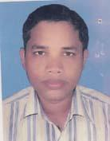 | DR. MD. YEAKUB ALI MUNSHI  F/Name: Md. Jalal Ahammad  M/Name: Late. Haricha Begum  BM & DC Reg. No: 32631  NID:  Cell: 01718466488  Address: Lecturer, Pharmacology Department, Noakhali Medical College, Noakhali  Blood Group: O+
160 | Voter No  LM-4900160 | DR. ASHISH KUMAR DEB NATH  F/Name: Late. Krishna Bandu Deb Nath  M/Name: Indubala Debi  BM & DC Reg. No: 23433  NID: 7528704122918  Cell: 01715007928  Address: 30, Central Road, Housing Estate, Maijdee, Noakhali  Blood Group: O+
161 | Voter No  LM-4900161  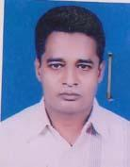 | DR. MD. REZAUL BARI  F/Name: Md. Nurul Alam  M/Name: Mrs. Ayesha Begum  BM & DC Reg. No: 27674  NID: 7528701101216  Cell: 01716338154  Address: Senior Medical Officer, Mohakhali, Diabetic Amity, Maijdee, Noakhali  Blood Group:
162 | Voter No  LM-4900162 | DR. MOHAMMAD SOHEL SARWER  F/Name: Abdur Rouf Moral  M/Name: Monwara Begum  BM & DC Reg. No: 34160  NID: 1594116381273  Cell: 01715376799  Address: Maa-Moi General Hospita, Main Road, Maijdee, Noakhali  Blood Group:
163 | Voter No  LM-4900163  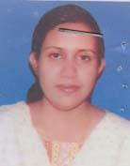 | DR. ISHRAT JAHAN  F/Name: Kabir Ahmed  M/Name: Josne Ara Begum  BM & DC Reg. No: 34161  NID: 1594116381274  Cell: 01711829594  Address: UHC, Begumganj, Noakhali  Blood Group: A+
164 | Voter No  LM-4900164 | DR. MD. FARIDUL ISLAM  F/Name: Md. Arshad Ali Molla  M/Name: Mrs. Johura Khatun  BM & DC Reg. No: 36060  NID: 7520708504934  Cell: 01712197397  Address: Apon Nibash Housing, Chowmohoni Chowrasta, Begumganj, Noakhali  Blood Group: O+
165 | Voter No  LM-4900165  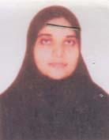 | DR. SHAILA ISLAM  F/Name: Dr. A. B. M. Hanif  M/Name: Late. Dr. Setara Begum  BM & DC Reg. No: 45568  NID: 7520708504935  Cell: 01727517052  Address: Apon Nibash Housing, Chowmohoni Chowrasta, Begumganj, Noakhali  Blood Group: B+
166 | Voter No  LM-4900166  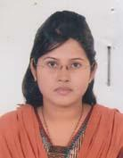 | DR. NABILA ANJUMAN  F/Name: Dr. Md. Sanaullah Meah  M/Name: Mrs. Zeenat Parveen  BM & DC Reg. No: 57948  NID: 2694066782370  Cell: 01718420417  Address: 40, Central Road Housing, Maizdee, Noakhali  Blood Group: O+
167 | Voter No  LM-4900167 | DR. MD. JAHANGIR ALAM BHUYIAN  F/Name: Md. Abu Bakar Siddique Bhuyian  M/Name: Jahanara Begum  BM & DC Reg. No:  NID: 01711282153,  Cell:  Address: Jahanara Hospital (Pvt),  Sonaimuri Chowrasta, PS. Sonaimuri,  Noakhali.  Blood Group: O+
168 | Voter No  LM-4900168  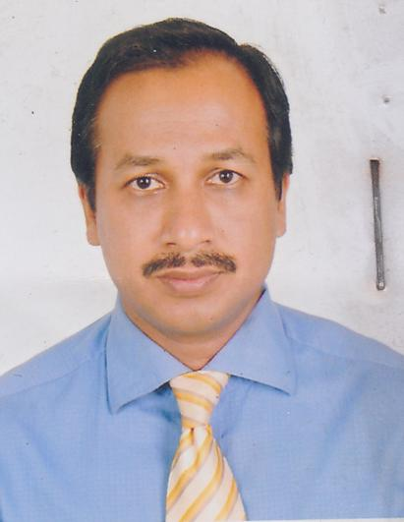 | DR. ABUL KHAYER AHMEDULLAH  F/Name: Md. Obaid Ullah  M/Name: Mrs. Habiba Khanam  BM & DC Reg. No: 24673  NID: 2696653267301  Cell: 01718325944  Address: Cosultant , Medicine, Upazila Health Complex, Ramgonj, Laxmipur.  Blood Group: O+
169 | Voter No  LM-4900169  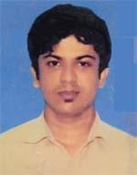 | DR. AHIDUL ISLAM  F/Name: Amirul Islam  M/Name: Most. Halima Islam  BM & DC Reg. No: 60962  NID: 1986262720503031  Cell: 01716591363  Address: Rabeya (Pvt.) Hospital, Doctor Para, Chowmohani, Noakhali  Blood Group: AB+
170 | Voter No  LM-4900170  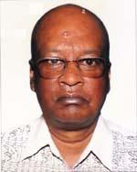 | DR. BIDYUT DATTA GUPTA  F/Name: Jitendr Kumar Datta Gupta  M/Name: Rani Datta Gupta  BM & DC Reg. No: 6685  NID: 7520704479042  Cell: 01713110013  Address: Shanilanir Palhaumuhani, Noakhali  Blood Group: O-
171 | Voter No  LM-4900171  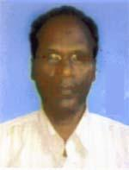 | DR. KAZI RIDWAN KAMAL  F/Name: Late Maulavi Abdul Rashid  M/Name: Late Ayesha Khatun  BM & DC Reg. No: 23527  NID: 7528704123944  Cell: 01757003374  Address: SMO, Noakhali Diabetis Hospital, Hospital Road, Maijdee, Noakhali  Blood Group: A+
172 | Voter No  LM-4900172 | DR. UTPAL KUMAR BARUA  F/Name: Swapan Kumar Barua  M/Name: Lila Barua  BM & DC Reg. No: 57696  NID: 2627209649253  Cell: 01711306863  Address: C/o Niramol Hospital Limited, Maizdee, Noakhali  Blood Group: B+
173 | Voter No  LM-4900173  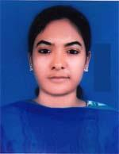 | DR. SIMI MAZUMDER  F/Name: Haripada Majumder  M/Name: Minaty Majumder  BM & DC Reg. No: 56636  NID: 7528702111885  Cell: 01717680441  Address: Vill-Maijdee, Post-Noakhali, P.s-Sadar, 3800, Dist-Noakhali  Blood Group: A+
174 | Voter No  LM-4900174  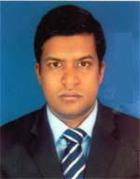 | MD. NAZMUL HASSAN RAZU  F/Name: Md. Abul Kalam Azad  M/Name: Masuma Akter  BM & DC Reg. No: 60081  NID: 2924709173356  Cell: 01913938788  Address: Vill-Baliakondi, Post-Biybag, P.s-Senbag, Dist-Noakhali  Blood Group: A+
175 | Voter No  LM-4900175 | DR. SAMIRA AFROZA RAHMAN  F/Name: Md. Oisur Rahman  M/Name: Afroza Begum  BM & DC Reg. No: 74237  NID:  Cell: 01625197813  Address: Eng. Delwar House, Sourdarpur, Kabirhat, Noakhali  Blood Group: n_a
176 | Voter No  LM-4900176  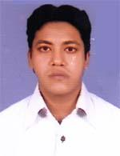 | DR. TANJIR RAFSAN KOBIR  F/Name: Late Humayun Kobir  M/Name: Hasina Nargis  BM & DC Reg. No: 71168  NID:  Cell: 01725748148  Address: Nurjahan Villa, Master Colony, Gonipur, Chowmuhani  Blood Group: O+
177 | Voter No  LM-4900177 | DR. MD. NAZMUL HASAN  F/Name: Md. Harun Or Roshid  M/Name: Nurun Nahar Begum  BM & DC Reg. No: 64808  NID: 19891594116437912  Cell: 01716380886  Address: M.O, UHC, Subornachar, Noakhali  Blood Group: O+
178 | Voter No  LM-4900178 | DR. SHAHADAT HOSSAIN  F/Name: Shahid Ullah  M/Name: Rezia Begum  BM & DC Reg. No: 62004  NID: 6125217236775  Cell: 01815440696  Address: Medical office, Companigonj , Upazilla Health Complex, Compigonj, Noakhali  Blood Group: A+
179 | Voter No  LM-4900179 | DR. SAIFUL AMIN  F/Name: Nurul Amin  M/Name: Jahanara Begum  BM & DC Reg. No: 69910  NID:  Cell:  Address: Wasekpur, Sonaimuri  Noakhali  Blood Group: B+
180 | Voter No  LM-4900180 | DR. KULSUM MAULA  F/Name: Golam Moula  M/Name: Ferdoush Ara Moula  BM & DC Reg. No: 69071  NID:  Cell: 01622233974  Address: Vill-Badarpur, Post-Bazra, Snaimori, Noakhali  Blood Group: A+
181 | Voter No  LM-4900181  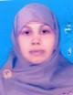 | DR. ROKHSANA RAHMAN  F/Name: Late Md. Ataur Rahman  M/Name: Rokeya Rahman  BM & DC Reg. No: 29896  NID: 2694811038569  Cell: 01816436264  Address: Farma Manjil , 1038, Masjid Road, Mazdee, Noakhali  Blood Group: B+
182 | Voter No  LM-4900182  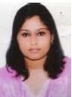 | DR. MOST. NUSRAT FATEMA BINTE NASER  F/Name: Dr. Md. Abu Naser  M/Name: Dr. Sultana Rabeya Khanam  BM & DC Reg. No: 77859  NID: 7520707501022  Cell: 01917305305  Address: Rabeya (Pvt) Hospital, College Road, Chowmuhani, Noakhali  Blood Group: O+
183 | Voter No  LM-4900183 | DR. MOHAMMED GIAS UDDIN  F/Name: Sultan Aftab Uddin  M/Name: Anowara Begum  BM & DC Reg. No: 36509  NID: 7528704123141  Cell: 01712196011  Address: Prime Hospital, Maizdee Court, Thana Sadar, Dist-Noakhali  Blood Group: A+
184 | Voter No  LM-4900184  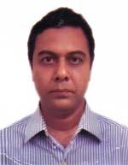 | DR. MD. MASUD HASAN  F/Name: Md. Aziz Ullah  M/Name: Sultana Begum  BM & DC Reg. No: 24833  NID: 7528704123618  Cell: 01815806110  Address: Consultant 250 Bed Hospital, Noakhali  Blood Group: B+
185 | Voter No  LM-4900185  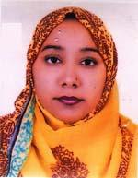 | DR. FATIMA TUZ ZOHORA  F/Name: Md. Abdul Jabber Chowdhury  M/Name: Firoza Begum  BM & DC Reg. No: 44778  NID: 2691648033460  Cell: 01718882313  Address: Prime Hospital, maizdee Court, Thana-Sadar, Dist-Noakhali  Blood Group: A-
186 | Voter No  LM-4900186  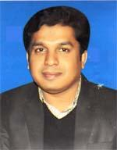 | DR. MD. SALEH AHAMMED SOHEL  F/Name: Md. Mobarak Ullah  M/Name: Mrs. Saleha Begum  BM & DC Reg. No: 44078  NID: 19787518377522297  Cell: 01712274362  Address: Maa Manzil, Kismatkorimpur, (Doctor Para), Chawmuhoni, Noakhali  Blood Group: O+
187 | Voter No  LM-4900187  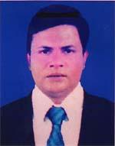 | DR. SHAHED AHMED  F/Name: Late Mohammad Ismail  M/Name: Mrs. Hosne Jahan  BM & DC Reg. No: 34420  NID: 1926709058442  Cell: 01675003877  Address: Flat-11, Delwar Villa, Mondol para, Chowmuhoni, Noakhali  Blood Group: O+
188 | Voter No  LM-4900188  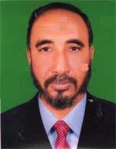 | DR. MD. KAMAL UDDIN  F/Name: Late Md. Amin Ullah  M/Name: Mrs. Noor Jahan Begum  BM & DC Reg. No: 15814  NID: 7520101463218  Cell: 01819613938  Address: 4/D Apon Nibash Housing, Nazirpur, Begumgonj, Dist-Noakhali  Blood Group: O+
189 | Voter No  LM-4900189 | DR. SYED MD. KAMRUL HOSSAIN  F/Name: Md. Ruhul Amin  M/Name: Mrs. Khodeza Begum  BM & DC Reg. No: 37064  NID: 7528008791547  Cell: 01712290326  Address: Jr. Consultant Surgery, 250 Beded General Hospital, Noakhali  Blood Group: O+
190 | Voter No  LM-4900190  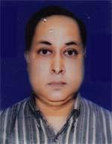 | DR. JASHIMMUDDIN AHMED CHOWDHURY  F/Name: Late Dr. Shamsuddin Ahmed Chowdhury  M/Name: Mrs. Moshfeka Banu  BM & DC Reg. No: 18801  NID: 7528704123588  Cell: 01711735810  Address: Senior consultant, 250 Bedded General Hospital, Maijdee, Noakhali  Blood Group: B+
191 | Voter No  LM-4900191  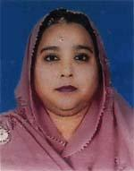 | DR. HASINA JAHAN  F/Name: Late Dr. Md. Habibullah  M/Name: Mrs. Salena Khatoon  BM & DC Reg. No: 22829  NID: 7528704123587  Cell: 01715174033  Address: School Health Clinic, Maijdee, Noakhali  Blood Group: B+
192 | Voter No  LM-4900192  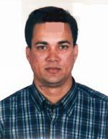 | DR. TAJUL ISLAM  F/Name: Late Md. Tariqul Islam  M/Name: Zakia Islam  BM & DC Reg. No: 25711  NID: 2696654324818  Cell: 01819212706  Address: H # 15, R # 10, Sector # 12/UHC , Uttara Model Town, Dhaka-1230  Blood Group: AB+
193 | Voter No  LM-4900193  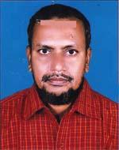 | DR. C. M. ZAHIRUL HAQ  F/Name: C. M. Azizul Haq  M/Name: Halima Akter  BM & DC Reg. No: 24348  NID: 7520704476914  Cell: 01712956960  Address: MCWC-Begumgonj, Noakhali.  Blood Group: A+
194 | Voter No  LM-4900194  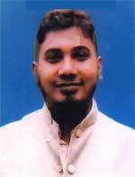 | DR. MD. TANUIR HAYDER  F/Name: Hafiz Golam Mowla  M/Name: Nahida Akter  BM & DC Reg. No: 48620  NID: 7528704121264  Cell: 01911111431  Address: Hafiz Mansoon, 105, Islam Bag R/A, Maijdee Court, Noakhali  Blood Group: B+
195 | Voter No  LM-4900195 | DR. MD. HASNAT JAKI CHOWDHURY  F/Name: Dr. A. K. M. Jahangir Chowdhury  M/Name: Adv. Hosneara Begum  BM & DC Reg. No: 53577  NID: 1926707048323  Cell: 01777767390  Address: Dream House, Plot # 10, Road # 36, Housing Estate, Maijdee, Noakhali  Blood Group: B+
196 | Voter No  LM-4900196  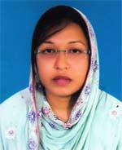 | DR. FARHANA MAHFUZ  F/Name: Dr. Md. Mahfuzul Haque  M/Name: Rawshan Ara Begum  BM & DC Reg. No: 62539  NID: 19892627205000038  Cell: 01717959846  Address: Dream House, Plot # 10, Road # 36, Housing Estate, Maijdee, Noakhali  Blood Group: O+
197 | Voter No  LM-4900197  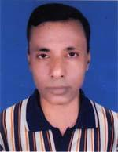 | DR. MOHAMMAD FARID UDDIN CHOWDHURY  F/Name: Late Abdulla Rashid Chowdhury  M/Name: Late Rahela Begum  BM & DC Reg. No: 23256  NID: 7522108076276  Cell: 01819165196  Address: RMO, 250 Bed General Hospital, Noakhali  Blood Group: AB+
198 | Voter No  LM-4900198 | DR. MD. KAMAL HOSSAIN  F/Name: Md. Abdul Hye  M/Name: Mrs. Noorjahan  BM & DC Reg. No: 35862  NID: 2692858502794  Cell: 01717494288  Address: Upazilla health Complex, Chatkhil, Noakhali  Blood Group: B+
199 | Voter No  LM-4900199 | DR. MOHAMMAD EMRAN HOSSAIN  F/Name: Mohammad Nurul Amin  M/Name: Begum Rokeya Akther  BM & DC Reg. No: 49042  NID: 1594116380879  Cell: 01719909531  Address: Community Eye Health Complex, sonapur, Ramgonj, Laxmipur  Blood Group: O+
200 | Voter No  LM-4900200 | DR. MD. MUJAHIDUL ISLAM  F/Name: Md. Nurul Islam  M/Name: Mrs. Khadiza Begum  BM & DC Reg. No: 45068  NID: 2611038789431  Cell: 01734620143  Address: Sonaimuri Medical Hospital, Sonaimuri, Noakhali  Blood Group: A+
201 | Voter No  LM-4900201 | DR. MD. UZIRE AZAM KHAN  F/Name: Md. Mofiz Uddin Khan  M/Name: Fatematuz Zohra  BM & DC Reg. No: 21163  NID: 2694263714757  Cell: 01722110369  Address: Department of Physiology Abdul Malek Ukil Medical College, Noakhali  Blood Group: A+
202 | Voter No  LM-4900202  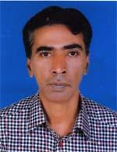 | DR. MD. BADRUL AHSAN  F/Name: Md. Habib Ullah  M/Name: Jahanara Bagum  BM & DC Reg. No: 26314  NID: 7511019737398  Cell: 01711003086  Address: House # 07, Holding #6/2, New Jailroad, Word-1, Maijee, Post-Noakhali, P.s-Sadar, Noakhali-3800  Blood Group: AB+
203 | Voter No  LM-4900203  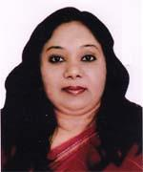 | DR. AFROZA KHANAM  F/Name: Md. Afaz Uddin Khan  M/Name: Regia Begam  BM & DC Reg. No: 28474  NID: 6716831739782  Cell: 01711003248  Address: Jail Road, Maijdee, Noakhali  Blood Group: B+
204 | Voter No  LM-4900204 | DR. MD. MAHFUZUR RAHMAN BABUL  F/Name: Late Mozammel Haque Chowdhury  M/Name: Late Anwara Begum  BM & DC Reg. No: 17612  NID: 7510780619810  Cell: 01713124690  Address: Modern Hospital. Maijdee Bazar, Noakhali  Blood Group: B+
205 | Voter No  LM-4900205  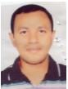 | DR. MD. GOLAM AZAM  F/Name: Md. Mamataz Uddin  M/Name: Saira Khatun  BM & DC Reg. No: 44023  NID: 1594115353812  Cell: 01911882768  Address: RMO, Upazilla Health Complex, Senbag, Noakhali  Blood Group: O+
206 | Voter No  LM-4900206 | DR. H. M. TOWFIQUR ALAM  F/Name: Dr. Md. Mofizul Alam  M/Name: Begum Mahmooda  BM & DC Reg. No: 53744  NID: 19867528704000012  Cell: 01705692717  Address: House # 12, Road # 05, Housing Estate, Maijdee, Noakhali  Blood Group: O+
207 | Voter No  LM-4900207  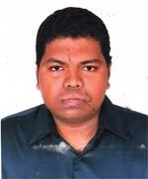 | MD. NAZMUL ALAM FARUQUEE  F/Name: Md. Faruque  M/Name: Shamsun Nahar  BM & DC Reg. No: 76476  NID:  Cell: 01688176418  Address: House No. 4, Road No. 23, Housing Estate, Maizdee, Noakhali  Blood Group: AB+
208 | Voter No  LM-4900208  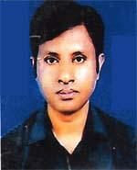 | DR. A. K. M. MUSHFIQER HAIDER  F/Name: A. K. M. Zulfiqer Haider  M/Name: Lutfeara Begum  BM & DC Reg. No: 29992  NID: 3012569554383  Cell: 01711703463  Address: Resident Surgeon, Noakhali, Sadar Hospital, Maijdee, Noakhali  Blood Group: O+
209 | Voter No  LM-4900209  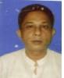 | DR. MOHAMMAD ZUBAIR  F/Name: Late Mahfuzur Rahman  M/Name: Mrs. Hasina Rahman  BM & DC Reg. No: 29383  NID: 2693622299894  Cell: 01754366277  Address: Upazilla Health Complex, Companiganj, Noakhali  Blood Group: O+
210 | Voter No  LM-4900210  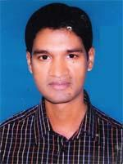 | DR. SHAWKAT AL EMRAN  F/Name: Mohammad Abdul Klaleque  M/Name: Mahera Begum  BM & DC Reg. No: 37156  NID: 7512111172501  Cell: 01711359069  Address: MO, UHC, Companigonj, Noakhali  Blood Group: A+
211 | Voter No  LM-4900211  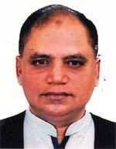 | DR. KHONDOKAR MAHMUDUL KABIR  F/Name: Khondokar Moazzem Husain  M/Name: Mahmuda Khatun  BM & DC Reg. No: 10918  NID: 7528705133662  Cell: 01711725111  Address: Lawyers Colony, Maijdee, Noakhali-3800  Blood Group: O+
212 | Voter No  LM-4900212  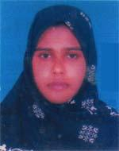 | DR. FATEMA JOAN  F/Name: Md. Sanaullah Miah  M/Name: Zinat Parvin  BM & DC Reg. No: 54347  NID: 2697556370783  Cell: 01671857669  Address: No. 40, Central Road, Housing Estate, Maijdee court, Noakhali  Blood Group: O-
213 | Voter No  LM-4900213 | DR. MD. MASUM BILLAH  F/Name: Abdul Hakim Hawlader  M/Name: Lili Akter  BM & DC Reg. No: A34697  NID:  Cell:  Address: UHC, Subanachar, Noakhali.  Blood Group:
214 | Voter No  LM-4900214  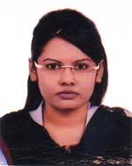 | DR. SIRAJUM MUNIRA JUTHI  F/Name: Dr. Shahadat Hossain Ratan  M/Name: Mrs. Naheeda Akhter  BM & DC Reg. No: 74502  NID: 2692848062245  Cell: 01733551515  Address: Chatkhil Sisu Hospital(Pvt), Chatkhil, Noakhali  Blood Group: AB+
215 | Voter No  LM-4900215  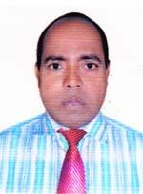 | DR. MD. SHOWKAT ALI  F/Name: Late Md. Shar Fuddin Biswas  M/Name: Mrs Saleha Khatun  BM & DC Reg. No: 16407  NID: 7521002618192  Cell: 01711472316  Address: Islamic Mission , Khilpara, chatkhil, Noakhali  Blood Group: A+
216 | Voter No  LM-4900216 | DR. NAZMUL ALAM  F/Name: Abdul Motin  M/Name: Rowshan Ara Begum  BM & DC Reg. No: 16993  NID: 2694814913773  Cell: 01732226647  Address: Biocom, Chatkhil, Noakhali  Blood Group: B+
217 | Voter No  LM-4900217  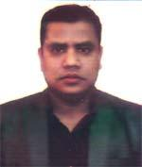 | DR. ALAMGIR HOSSAIN  F/Name: Late Abdul Jabber Patwary  M/Name: Mrs. Ohida Begum  BM & DC Reg. No: 50230  NID: 19837511066000015  Cell: 01717824461  Address: Upazilla Health Complex, chatkhil, Noakhali  Blood Group: B+
218 | Voter No  LM-4900218  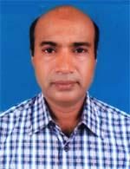 | DR. MD. NUR NOBI  F/Name: Nur Mohammad  M/Name: Nur Jahan  BM & DC Reg. No: 26954  NID: 7528708150013  Cell: 01819138569  Address: Ratna Medical Hall, Datterhat, Sadar, Noakhali  Blood Group: AB+
219 | Voter No  LM-4900219 | DR. SOPAN CHANDRA DER NATH  F/Name: Radha Gobinda Deb Nath  M/Name: Khana Bhowmik Prova  BM & DC Reg. No: 53474  NID:  Cell: 01920253959  Address: Upazilla Health Complex, Kabirhat, Noakhali  Blood Group: B+
220 | Voter No  LM-4900220  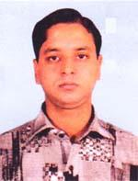 | DR. MOHAMMAD MAHBUBUR RAHMAN  F/Name: Late Mohammad Mofijur Rahman  M/Name: Tanzu Begum  BM & DC Reg. No: 45884  NID: 19832690421369741  Cell: 01972717409  Address: General Hospital , Chowmuhani, Noakhali.  Blood Group: A+
221 | Voter No  LM-4900221  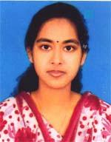 | DR. NABILA CHOWDHURY  F/Name: Dr. Md. Shahabuddin  M/Name: Dr. Hasina Begum  BM & DC Reg. No: 74256  NID: 19917520706000093  Cell: 01972717409  Address: General Hospital, Chaumuhani, Noakhali  Blood Group: A+
222 | Voter No  LM-4900222  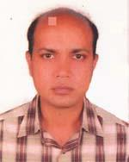 | DR. MUHAMMAD MONIR HOSSAIN  F/Name: Muhammad Abdul Awal  M/Name: Suraiya Awal  BM & DC Reg. No: 31668  NID:  Cell: 01715019489  Address: Prime Hospital , Noakhali  Blood Group: A+
223 | Voter No  LM-4900223  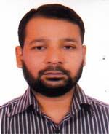 | DR. MOHAMMAD ALA UDDIN  F/Name: Abul Bashar  M/Name: Noor Jahan Begum  BM & DC Reg. No: 45490  NID: 7512171192438  Cell: 01716617276  Address: Maa O Shishu Hospital, Maijdee, Noakhali  Blood Group: B+
224 | Voter No  LM-4900224  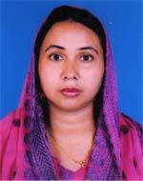 | DR. SONY PARVIN  F/Name: Md. Ayub Ali  M/Name: Tahmina Akter  BM & DC Reg. No: 52009  NID: 9196203120735  Cell: 01717755630  Address: 309/220 Court Station Road, Maijdee Court, Noakhali  Blood Group: A+
225 | Voter No  LM-4900225 | DR. KHALEDA AKTAR KHANAM  F/Name: Late Shoaib Ahmed Khan  M/Name: Mrs. Jahanara Khanam  BM & DC Reg. No: A30256  NID: 1594116394847  Cell:  Address: Khan Bari Hospital Road, Maijde Noakhali.  Blood Group: O+
226 | Voter No  LM-4900226  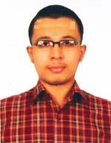 | DR. M. A. JANNAT KHAN KHADEM  F/Name: Md. Kauser Khan Khadem  M/Name: Nargis Begum  BM & DC Reg. No: 71655  NID: 19912693625000418  Cell: 01745915718  Address: Prime Hospital Maijdee, Noakhali.  Blood Group: B+
227 | Voter No  LM-4900227  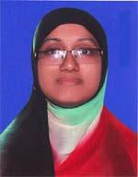 | DR. FARZANA RAHMAN  F/Name: Late Md. Mamunur Rahman  M/Name: Parvin Akter  BM & DC Reg. No: 64441  NID: 0695123268848  Cell: 01750003626  Address: Navana Tower, Flat #6, House #01, Road # 11, Housing Estate, Maijdee, Noakhali  Blood Group: B+
228 | Voter No  LM-4900228  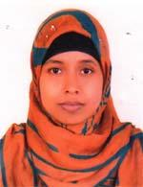 | DR. UMME SALMA  F/Name: Md. Abdul Jalil  M/Name: Setara Begum  BM & DC Reg. No: 71206  NID: 2611038875612  Cell: 01714960481  Address: Wood Land Hospital, Maijdee, Noakhali  Blood Group: B+
229 | Voter No  LM-4900229  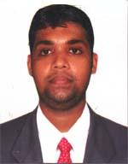 | DR. MD. MAMUNUR RASHID  F/Name: Md. Belal Hossain  M/Name: Mohor Akter  BM & DC Reg. No: 74849  NID: bb0913089  Cell: 01718573825  Address: Maddam Karimpur, Sonapur, Sadar, Noakhali  Blood Group: O+
230 | Voter No  LM-4900230  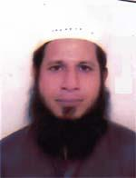 | DR. MOHIUDDIN HUMAYUN KABIR CHOWDHURY  F/Name: Late Dr. Badiuzzaman Chowdhury  M/Name: Rokeya Zaman  BM & DC Reg. No: 29895  NID: 2694811038572  Cell: 01816436263  Address: 250 Bed General Hospital, Maijdee, Noakhali  Blood Group: A+
231 | Voter No  LM-4900231 | DR. F.M. SHAHADAT HOSSAIN ROMEL  F/Name:  M/Name:  BM & DC Reg. No:  NID:  Cell:  Address: a  Blood Group:

